Tent #1 Parts - 2” diameter steel poles

3 four-way connectors
6 three-way connectors
6 short Horizontal poles
6 long Horizontal poles
6 Peak poles
6 Leg poles
Approx 36 Bungee cords with balls (bungees attach the tarp to the frame)
12 by 20 silver tarp
6 ratchets and straps (aka: tie downs or guy lines)
6 tennis balls with slits
Flagging tape
Heavy hammer to put up; rubber mallet to take down
TENT #1 SET-UP DIRECTIONS
Hints:
- Minimum of 3 people including someone who can handle the heavy hammer for set-up.
- Keep the parts for each tent separated; set up one tent at a time!
- Do not set up on a windy day.
- THREE legs on each side.

Set-Up Steps:
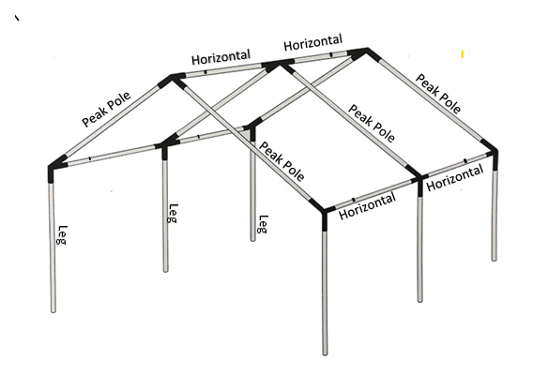
- Work in the location in which you plan to erect the tent.
- Put the roof frame together on the ground FIRST.
- Couple short “Horizontal” and long “Horizontal” poles together.
Lay coupled Horizontal poles parallel to fence.
  - Lay “Peak” poles perpendicular to horizontal poles.
  - Two types of Connectors: 3-way and 4-way.
3-way connectors are used at either end of the tent.
4-way connectors are used on the interior of the framework.
Lay out the connectors on the ground.
NOTE: Each 4-way connector has two bent receiving ends and two straight receiving ends. The Horizontal poles are inserted into the straight receiving ends of the 4-way connectors.

  - Assemble Horizontal and Peak roof poles together using all of the connectors.
- Install the tarp BEFORE lifting this structure up onto the legs.
The tarp HOLDS the metal roof structure together!
- Lay tarp (Silver side up) alongside a long side of the frame and pull it over the roof. Attach the tarp to the frame by putting a bungee cord through each grommet in the tarp and then wrapping the cord around a pole.
NOTE: Put 2 bungees through the corner grommet on each of the 4 corners of the tarp. Wrap one bungee around Horizontal and one bungee around Peak pole.
- Lay legs on the ground next to each connector into which they will be inserted.
- Stand a person at each connector with a leg on one of the long sides. Lift this side of the frame together and insert a leg pole into each connector.
- Move to the other long side and repeat the process.
- Hammer six steel stakes into the ground. Hammer them in at an angle, approximately 4’ away from the base of the leg, in line with the leg and peak pole. Do not go out diagonally from the tent, as that will pull the connectors away from the horizontal poles.
- Wrap the long side of a ratchet strap around the connector at the top of the leg pole. Wrap the short side around the stake a couple of times and attach it to the stake. Use the ratchet to tighten the strap. (It’s often easier to pull down on the strap when using the ratchet to tighten the strap.) Bundle up the excess strap so it doesn’t flap around in the wind. Repeat - tie down EVERY leg pole with a ratchet strap.
- If the ratchet strap is not bright orange, attach flagging tape to each strap to help prevent someone from walking into it/tripping on it.
- Put a tennis ball over the head of each stake.
*******************************

TENT TAKE-DOWN DIRECTIONS
Do ASAP After the October USDAA trial!
Hints:
- A minimum of 4 people is needed.
- Do not attempt the take down on a windy day.
- Keep the parts for each tent separated; take down one tent at a time.
- Work gloves with a rubberized palm are recommended to enhance grip. Sometimes the poles need to be strongly twisted in order to get them apart from connectors.

Take-Down Steps for Either Tent
- Remove all ratchet straps tying down the leg poles and pull the stakes out so no one trips on them.
NOTE: If a pole is stuck and hard to remove from the ground use a rubber mallet to hit the stuck pole to loosen it. The rubber mallet is stored in the orange plastic bucket in the trailer.
- Put one person at each leg on one long side. Lift up together and pull a leg out of its connector. Extra person can help remove the stuck legs by twisting the poles or use the rubber mallet. Lower that side of the frame.
- Repeat on the other side.
- Remove tarp. Leave bungees attached to tarp if it will be reused. If tarp is weathered or ripped, make a note to purchase a new one before tent assembly day next spring. Same for ratchets, ropes, and bungees.
- Disassemble roof frame.
- Bundle poles according to the labels and bungee them. Do not make bundles too heavy.
- Store pole bundles in the trailer beneath the wooden shelves.
- Fold tarp and store in Tent bin #1.
- Go out for a beer and celebrate!

