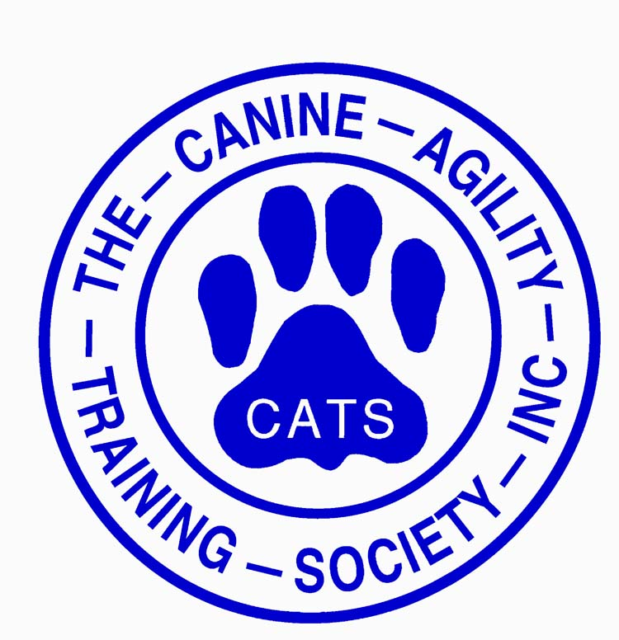
Laura Dolan Seminar
Sunday, February 23, 2025
Registration Form

January 31 Registration Opens for CATS Members
February 10 Registration Opens for Non-Members

SEMINAR
Inside arena at Monadnock Humane Society, 101 W. Swanzey Road, Swanzey, NH
Session A Masters Check in 7:30-8:00, Session 8:00-12:00
Session B Novice & Intermediate Check in 12:30-1:00, Session 1:00-5:00
Bring your own food and beverages. Water on site.

REGISTRATION FEES
Session A or B Working Spot CATS Member | $100/session
Session A or B Working Spot Non-Member | $150/session
Session A or B Audit CATS Member | $25/session
Session A or B Audit Non-Member | $35/session

MEMBERSHIP BENEFITS
For more information on CATS Membership: https://canineagility.org/membership/

PAYMENT
- Make check out to CATS.
RETURN
- Form by email: ann.driscoll@comcast.net
- Form and payment by US mail:
CATS Laura Dolan 2.23.25 Seminar
c/o Ann Driscoll
7 Seaborne Drive
Dover, NH 03820

CONFIRMATION of SPOT
There are 6 Working Spots/session and Unlimited Audits. Spot is confirmed once registration and payment are received. First come, first serve.

WEATHER
The decision to cancel will be made by 5:00am Sunday, February 23. Announcements are made via email from Chris Wentworth (chrisfwentworth@gmail.com) or Ann Driscoll (ann.driscoll@comcast.net) and Facebook post to Canine Agility Training Society
https://www.facebook.com/CanineAgilityTrainingSociety

QUESTIONS:
Chris Wentworth 603-313-9998 or Ann Driscoll ann.driscoll@comcast.net

Registration Form for CATS Laura Dolan Seminar, Sunday, February 23, 2025
Handler:
CATS Member: (Yes/No)
Phone: Email:
Dog Name: Breed & Age: Jump Height:
Registration Fees
Session A or B Working Spot CATS Member | $100/session
Session A or B Working Spot Non-Member | $150/session
Session A or B Audit CATS Member | $25/session
Session A or B Audit Non-Member | $35/session

Registering for (indicate choice)
CATS MEMBER  ___Session A Masters Working (8:00-12:00)  ___Session B Novice/Intermediate Working (1:00-5:00)  ___Session A Masters Audit  ___Session B Novice/Intermediate Audit | NON-MEMBER  ___Session A Masters Working (8:00-12:00)  ___Session B Novice/Intermediate Working (1:00-5:00)  ___Session A Masters Audit  ___Session B Novice/Intermediate Audit

AMOUNT ENCLOSED
Check Payable to CATS $______ Mail to: Ann Driscoll, 7 Seaborne Drive, Dover, NH 03820

Teams with Working Spots please answer these questions for the Instructor:

- What is this team’s agility experience?

- What do you hope to learn from this seminar?

- Is there anything else you'd like the instructor to know about you and your dog?

