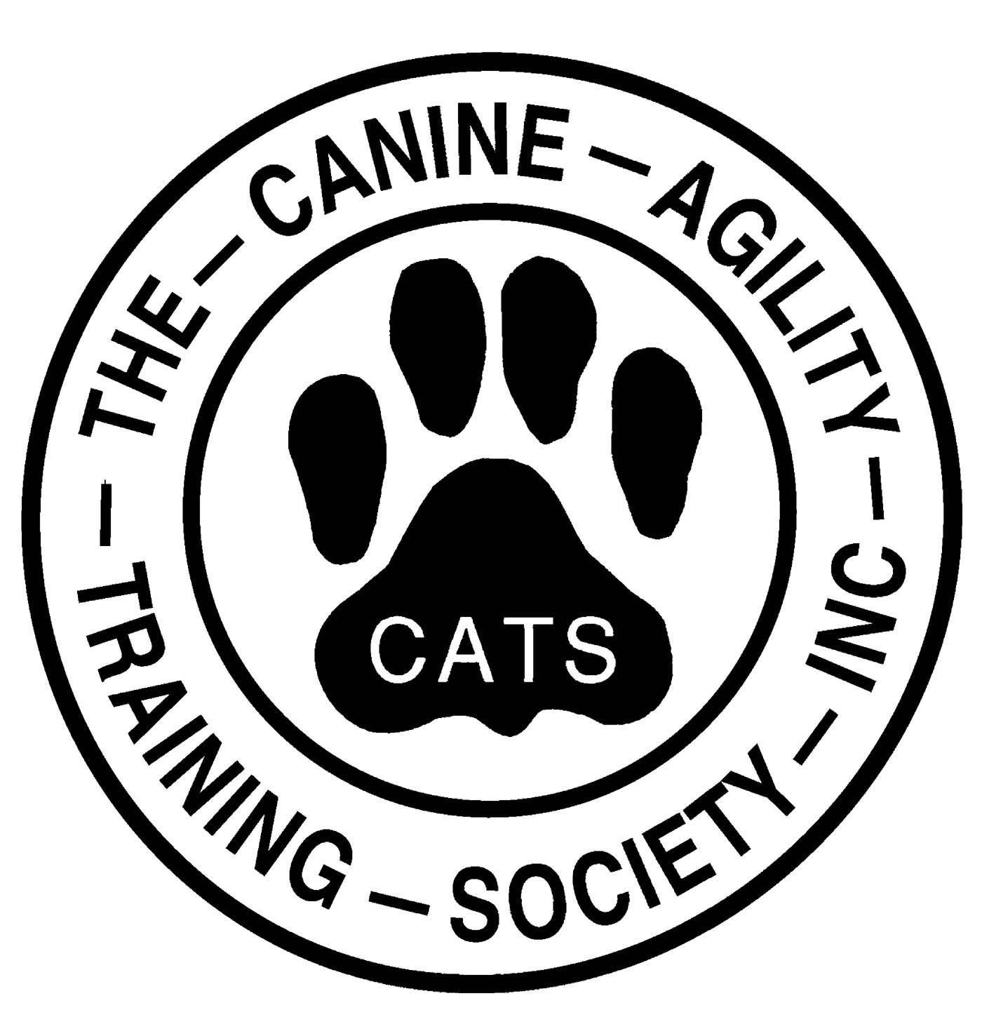
Sign Up for 2026 CATS Committees & Trials
Thank you for helping support your club!

Your Name: ____________________________________ Date: ____________________

This is part of Annual Membership Renewal. Please return your completed form by Feb 1st to ann.driscoll@comcast.net OR Ann Driscoll, 7 Seaborne Drive, Dover, NH 03820.

Working Membership | Supporting Membership
- Try to attend membership meetings at least twice per year.  - Active participation on a committee or with a club activity.  - Work one spring or fall equipment migration.  - At least twice per year:  - Assist with physical setup or breakdown for a Club trial (requires moving equipment) OR  - Serve as daylong dedicated worker at a Club trial (includes breaks to run your own dog) | - Try to attend membership meetings at least twice per year.  - Help at trials and with activities and committees is encouraged but not required.

CATS TRIALS
Please indicate trial(s) you will help with this year (please mark your calendars):
 | 2026 DATES | LOCATIONS | TRIALS I PLAN TO WORK:
CPE | March 21-22 | American K9 Country, Amherst, NH
USDAA | June 5, 6 & 7 | Data Driven, Springfield, VT
CPE | Sept 12 & 13 | Monadnock Humane Society, Swanzey, NH
USDAA | Oct 3-4 | Data Driven, Springfield, VT

CATS COMMITTEES
Please indicate committee(s) you will serve on this year
I WOULD LIKE
TO SERVE ON:
AUDIT - Conducts annual audit of the Club financial records.
EQUIPMENT - Manages and maintains Club’s agility equipment
EVENT - Plans/carries out CPE and USDAA agility trials, primary CATS fundraising events.
FINANCE - Manages Club’s budget.
GROUNDS - Conducts maintenance of the outdoor arena and surrounding areas
LIBRARIAN & HISTORIAN - Manages book collection, records Club history and policies.
MEMBERSHIP - Recruitment and orientation of new members.
NOMINATING - Recruits and nominates members for the Board of Directors.
SEMINAR - Plans and carries out seminars for members and the agility community.
SHOW & GO/RUN THRU - Plans/carries out show & go and run thrus.
SOCIAL - Plans and carries out social functions, maintains rainbow bridge memorials.
SOCIAL MEDIA - Administers website, Facebook posts, Google Groups, Instagram posts.
TRAINING - Plans and arranges training sessions for Club members.

