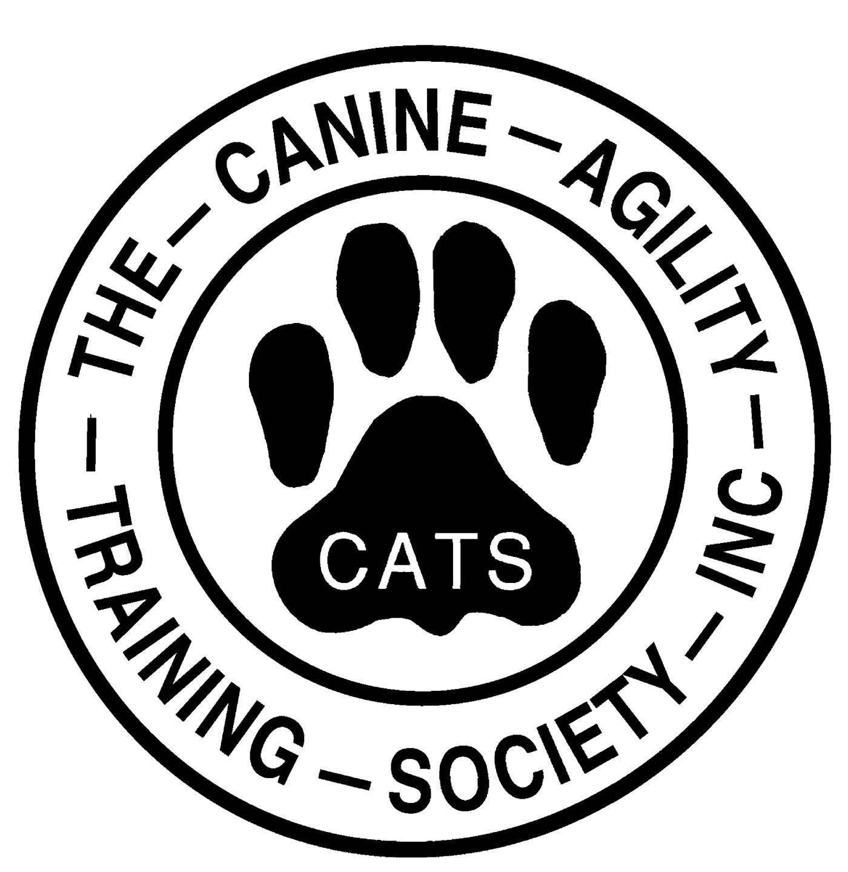 | NEW MEMBER APPLICATION (rvd Jan 2026)  The Canine Agility Training Society Inc. (CATS)  Application Process:  - Applicant finds a sponsor who has been a CATS member for at least one year.  - Applicant submits pages 1 & 2 of this form along with dues. Membership is approved once accepted by the Treasurer.  - Keep page 3 for yourself. It contains important CATS info.  - Any questions? Email CanineAgilityNH@gmail.com  - Mail form with check payable to CATS to:
CATS c/o Monadnock Humane Society
101 W. Swanzey Road
Swanzey NH 03446

Name: Date:

Address:

Cell Phone: Home Phone:

Email:

I consent to having my name, address, email, and phone listed in the CATS membership list, which is provided only to members and will enhance communication between members: Yes No

- Please list your dog(s) which may participate in CATS activities and provide a brief description of each. Dogs must be current on vaccinations to participate.

- Who is your CATS sponsor?

- Why do you want to join CATS?

- Briefly describe your prior agility and/or dog training experience.

- Memberships are renewed annually. Which type of membership are you applying for?
(Membership details and requirements are on the last page)
- Working $75
- Supporting $150
- Junior (Ages 7-18) $37.50

In consideration of the acceptance of this application, I agree to the following for this year:

- I agree to abide by the rules and regulations of the Canine Agility Training Society (CATS) and any other corresponding rules and regulations and procedures for any class, event, activity, or meeting.

- I hereby certify that my dog or other dogs brought by me to a CATS function is not a hazard to persons, other animals, or property and that the dog’s rabies and other vaccinations will be kept current in accordance with the requirements of the state in which the dog resides.

- I acknowledge all hazards presented by events, classes, activities, meetings, and corresponding event premises, including, but not limited to, the condition of the flooring, footing, stairways, walks, halls, lighting, security measures or lack thereof, electrical appliances, fittings, show rings, parking areas, and the presence of unfamiliar animals and people; the participant and owner assume the entire risk of any harm arising from these.

- I hereby release CATS (including officers, directors, employees, and members thereof) and that of any sites, training centers and other sites used for CATS Club activities and hold them harmless from all present and future loss, injury, damage, claims, demands and liabilities involving the dog, event, or event premises. I hereby specifically assume sole responsibility for, and agree to all expenses (including legal fees) by reason of the liability imposed by law on any of the aforementioned parties for damages because my/our participation in CATS activities, events or meetings, howsoever such injury, or death may be caused, and whether or not the same may have been caused or may be alleged to have been caused by the negligence of the aforementioned parties or any of their employees or agents or any other persons.

- I agree to work with my dog in agility training in a manner that never threatens his/her safety or well-being. I recognize that it is important that a dog not lose confidence or be physically harmed as a part of his/her participation in the sport of agility and will do all I can to keep training and practice safe and fun. In keeping with Club philosophy, I agree to train my dog using positive, reward-based methods that are advocated by CATS as well as the national agility sanctioning organizations of this country.

I agree to abide by the following Code of Conduct:

- Treat others with dignity and respect, as beings inherently worthy of esteem, honor, and high regard, irrespective of our many differences.

- In our words and actions, strive to create and maintain a positive and harmonious atmosphere at the Club, one that will enhance the bond we seek to develop with our dogs as we train them, and that will promote fellowship and goodwill toward each other.

- In our interactions with each other, practice personal integrity, accept responsibility for our actions, and when we disagree, communicate with courtesy, act ethically, and above all, strive to seek and tolerate a constructive outcome.

I have read, understand, and acknowledge the above Agreement and agree to abide by it and by the CATS Club Bylaws. Bylaws available at https://canineagility.org/cats-by-laws

Print Name of Applicant:

Signature of Applicant: Date:

If applicant is under the age of 18,
Signature of Parent or Legal Guardian Date:

SAVE THIS PAGE -- CATS Membership Info 2026
IMPORTANT DATES: CATS TRIALS
March 21 & 22 CPE - at American K9 Country Amherst, NH
June 5, 6 & 7 USDAA at Data Driven, Springfield, VT
Sept 12 & 13 CPE - at American K9 Country Amherst, NH
Oct 3 & 4 USDAA at Data Driven, Springfield, VT

MEMBERSHIP MEETINGS are 7pm on Zoom the second Wednesday of every other month: March 11, May 13, July 8, September 9, November 11
ANNUAL MEMBERSHIP MEETING is December 9

Member Benefits:
- Use of CATS arena and agility equipment (must have equipment safety orientation and be an Advanced Handler or be supervised by an Advanced Handler).
- Discount on CATS agility seminars.
- Access to CATS agility classes.
- Discount on MHS agility classes.
- Discount on trial entries for trial workers.
- Attend Club meetings, vote on business, serve on the Board of Directors, be an Officer.

Types of Membership and Requirements
Working Membership:
- Try to attend membership meetings at least twice per year.
- Active participation on a committee or with a club activity.
- Work one spring or fall equipment migration.
- At least twice per year:
- Assist with physical setup or breakdown for a Club trial (requires moving equipment) OR
- Serve as daylong dedicated worker at a Club trial (includes breaks to run your own dog)

Supporting Membership:
- Try to attend membership meetings at least twice per year.
- Help at trials and with activities and committees is encouraged but not required.

CATS Committees:
- Audit: Conducts annual audit of the Club financial records.
- Equipment: Manages and maintains Club’s agility equipment.
- Event: Plans/carries out CPE and USDAA sanctioned agility trials, which are our primary fundraising activities for the Club.
- Finance: Manages Club’s budget.
- Grounds: Conducts maintenance of the outdoor arena and surrounding areas
- Librarian & Historian: Manages book collection, records Club history and policies.
- Membership: Recruitment and orientation of new members.
- Nominating: Recruits and nominates members for the Board of Directors.
- Seminar: Plans and carries out seminars for members and the wider agility community.
- Show & Go: Plans and carries out show & go and run thru events for members and non-members.
- Social: Plans and carries out social functions, maintains rainbow bridge memorials.
- Social Media: Administers website, online calendar, Facebook page, Google Groups.
- Training: Plans and arranges training sessions for Club members.

Social Media:
General Communication for members is through our Google Group: Canine Agility Training Society CATS
Website: Canineagility.org
Facebook page: Canine Agility Training Society - Like and Follow!

